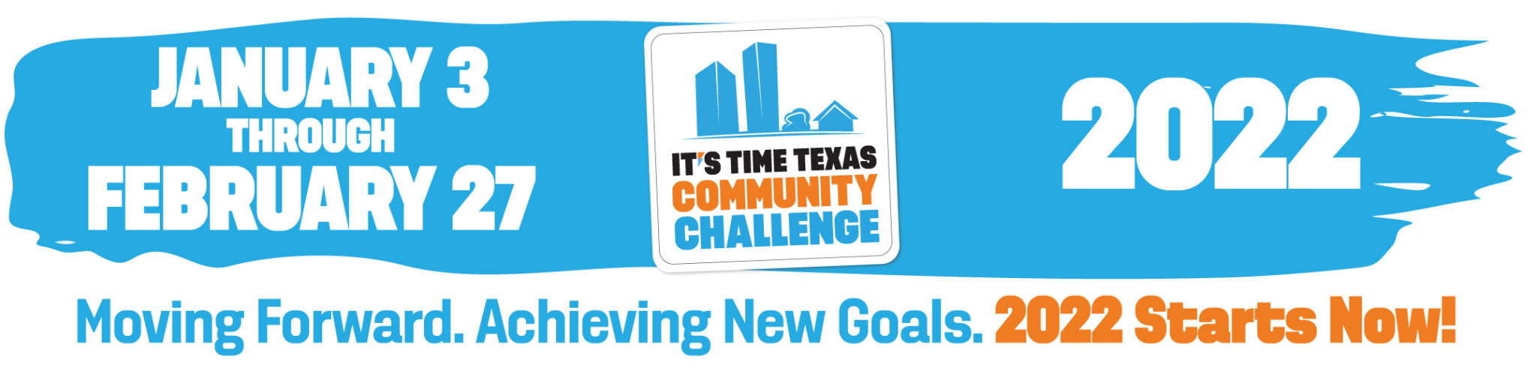

The It’s Time Texas Community Challenge is a statewide competition that inspires individuals, schools, organizations/employers, and cities across Texas to engage in healthy activities in support of a healthier community. Help our community win by logging your healthy actions, such as drinking water, going for a walk, or eating a nutritious snack, in the Community Challenge app. It’s FREE and EASY to sign up at: Register.ITTCommunityChallenge.com.

[YOUR LOGO]

Register today to automatically earn 750 points for your community!

Register.ITTCommunityChallenge.com

