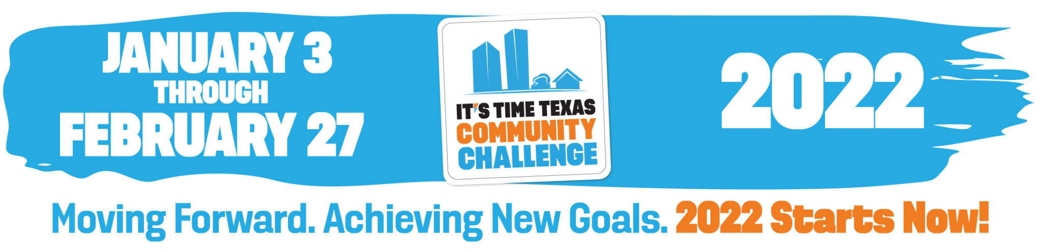

The It’s Time Texas Community Challenge is a statewide competition that inspires Mayors, CEOs, employers, schools, cities, communities, and individuals across Texas to engage in healthy activities in support of a healthier community.
Join us for our [INSERT HEALTHY GROUP ACTIVITY] and help our community win by logging it as one of your healthy activities in the Community Challenge app!

[YOUR LOGO HERE]
DATE & TIME: [INSERT HERE]
LOCATION: [INSERT ADDRESS OR URL LINK]

