Partner Email Templates – Individual Participant Promotion

What is included in this document and how do I use it?
- These email templates serve as a first-touch communication with your community, school district employees, or municipal employees.
- The highlighted yellow portions of the template must be edited in order to fit your specific organization and, if applicable, historical Community Challenge participation.
- There are four types of email templates included in this document, but please feel empowered to edit the email templates to best fit your type of organization and communication style.
  - Returning Partners: School Districts
  - Returning Partners: Local Government & Community Orgs
  - New Partners: School Districts
  - Returning Partners: Local Government & Community Orgs
Who is this document for?
- This document is for local health champions; this It’s Time Texas’ primary point-of-contact or other advocates for health within a partner organization. Included in this document are various email templates to deploy to individuals within your organization / “sphere of influence” promoting registration for this year’s 2023 It’s Time Texas Community Challenge.
What is the overall purpose of these promotional email templates?
- Establish you, the Health Champion, as an advocate for the 2023 Community Challenge within your organization
- Educate employees/community members about the Community Challenge
- Provide specific registration instructions to employees/community members
- Encourage recipients to register for the Community Challenge and download the mobile app

Email Template for Returning Partners: School Districts

Good <time of day>!
<ISD Name> is excited to compete in the 2023 It’s Time Texas Community Challenge. But we can’t do it alone! We need all-hands-on-deck to have a chance to win. See below for a quick refresher of the Challenge and information on how to register.
<Add information regarding last year’s participation, any specific goals for this year>
Community Challenge Refresher
- It’s Time Texas Community Challenge unites Texans from across the state to build a healthier Texas. This free, fun eight-week competition challenges Texans to unite as communities and work together to create healthy habits. And like any good competition, there are over $2,500 in weekly prizes!
- The 2023 Challenge kicks off on January 9th. Earn points by reporting your healthy actions, exploring nearby parks, and participating in healthy group activities. Your earned points will count towards <ISD Name>’s total as we compete against nearby school districts.
- Start the new year off on the right foot! The Community Challenge is a great tool to help you prioritize your personal health.
Get Started
- Scan the Community Challenge QR code with your phone or click here.
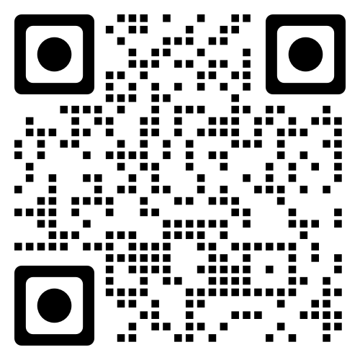
- Spread the word to colleagues and friends. Use the referral functionality in the app to send out an invitation to register! Remember, the more people who register, the more points earned for our school district!
If you have any inquiries regarding the Community Challenge, please reach out to support@ittcommunitychallenge.com and a member of the It’s Time Texas Community Challenge team will be in touch.
Looking forward to a great Community Challenge!
<Insert Signature>

Email Template for Returning Partners: Local Governments & Community Orgs

Good <time of day>!
<Organization Name> is excited to compete in the 2023 It’s Time Texas Community Challenge. But we can’t do it alone! We need all-hands-on-deck to have a chance to win. See below for a quick refresher of the Challenge and information on how to register.
<Add information regarding last year’s participation, any specific goals for this year>
Community Challenge Refresher
- It’s Time Texas Community Challenge unites Texans from across the state to build a healthier Texas. This free, fun eight-week competition challenges Texans to unite as communities and work together to create healthy habits. And like any good competition, there are over $2,500 in weekly prizes!
- The 2023 Challenge kicks off on January 9th. Earn points by reporting your healthy actions, exploring nearby parks, and participating in healthy group activities. Your earned points will count towards <Organization Name>’s total as we compete against nearby communities.
- Start the new year off on the right foot! The Community Challenge is a great tool to help you prioritize your personal health.
Get Started
- Scan the Community Challenge QR code with your phone or click here.
- Spread the word to colleagues and friends. Use the referral functionality in the app to send out an invitation to register! Remember, the more people who register, the more points earned for our organization!
If you have any inquiries regarding the Community Challenge, please reach out to support@ittcommunitychallenge.com and a member of the It’s Time Texas Community Challenge team will be in touch.
Looking forward to a great Community Challenge!
<Insert Signature>

Email Template for First Time Partners: School Districts

Good <time of day>!
<ISD Name> is excited to join over 20,000 Texans across 300 communities throughout Texas to compete in the 2023 It’s Time Texas Community Challenge. This eight-week, statewide health competition serves as a fun, free way for us to prioritize our health while going head-to-head against nearby school districts, while demonstrating our commitment to health! But we can’t do it alone; we need all-hands-on-deck to have a chance to win! See below for information regarding the Challenge and next steps.
What is the Community Challenge?
- Kick off the New Year with simple healthy habits and be part of something that impacts more than just you! Be part of building a healthier Texas by participating in the It’s Time Texas Community Challenge from Jan. 9 to March 5.
- Download the Community Challenge app and compete. Report daily healthy habits such as drinking water, going for a walk, and eating a healthy snack to earn points. At the end of the competition, the top individuals, school districts, organizations, and communities will win prizes, be recognized, and earn bragging rights until 2024!
Why are we participating?
- ISDs: <ISD Name> Is committed to providing <teachers/staff/employees> with opportunities that allow you to prioritize your personal wellbeing. You work hard to serve your students, colleagues, and community—the Community Challenge acts as a tool to support your physical and mental wellbeing in a fun and unique way, all while building community and developing healthy habits.
Get Started
- Scan the Community Challenge QR code with your phone or click here.
- Spread the word to colleagues and friends. Use the referral functionality in the app to send out an invitation to register! Remember, the more people who register, the more points earning points for our organization!
If you have any inquiries regarding the Community Challenge, please reach out to support@ittcommunitychallenge.com and a member of the It’s Time Texas Community Challenge team will be in touch.
Looking forward to a great Community Challenge!
<Insert Signature>

Email Template for First Time Partners: Local Governments & Community Orgs

Good <time of day>!
<Organization Name> is excited to join over 20,000 Texans across 300 communities throughout Texas to compete in the 2023 It’s Time Texas Community Challenge. This eight-week, statewide health competition serves as a fun, free way for us to prioritize our health while going head-to-head against nearby communities while demonstrating our commitment to health! But we can’t do it alone; we need all-hands-on-deck to have a chance to win! See below for information regarding the Challenge and next steps.
What is the Community Challenge?
- Kick off the New Year with simple healthy habits and be part of something that impacts more than just you! Be part of building a healthier Texas by participating in the It’s Time Texas Community Challenge from Jan. 9 to March 5.
- Download the Community Challenge app and compete. Report daily healthy habits such as drinking water, going for a walk, and eating a healthy snack to earn points. At the end of the competition, the top individuals, school districts, organizations, and communities will win prizes, be recognized, and earn bragging rights until 2024!
Why are we participating?
- Local Gov: <Organization Name> is always looking for dynamic wellness initiatives to serve our <employees/community>. The Community Challenge is a great event to help prioritize community health while having fun, building support, and developing healthy habits.
Get Started
- Scan the Community Challenge QR code with your phone or click here.
- Spread the word to colleagues and friends. Use the referral functionality in the app to send out an invitation to register! Remember, the more people who register, the more points earning points for our organization!
If you have any inquiries regarding the Community Challenge, please reach out to support@ittcommunitychallenge.com and a member of the It’s Time Texas Community Challenge team will be in touch.
Looking forward to a great Community Challenge!
<Insert Signature>

